

**Arterial Stiffness, Cognition, and Equol Study**

in collaboration with

****

**The National Centralized Repository for Alzheimer’s Disease and Related Dementias (NCRAD)**

*Biofluid Collection, Processing and Shipment*

*Manual of Procedures*

*Version 1.0*

*March 2023*

Table of Contents

[1.0 Abbreviations 4](#_Toc130279249)

[2.0 Purpose 5](#_Toc130279250)

[3.0 NCRAD Information 6](#_Toc130279251)

[3.1 NCRAD Contacts 6](#_Toc130279252)

[3.2 Hours of Operation 6](#_Toc130279253)

[3.3 Holiday Schedules 7](#_Toc130279254)

[3.4 Holiday Observations 7](#_Toc130279255)

[4.0 NCRAD Laboratory Collection 7](#_Toc130279256)

[4.1 Site Required Equipment 7](#_Toc130279257)

[4.2 Pre-intervention visit (urine) 8](#_Toc130279258)

[4.3 Biofluid Collection Schedule 8](#_Toc130279259)

[4.4 Biofluid Collection Charts 10](#_Toc130279260)

[4.4.1 Biofluid Collection for Urine Visits 10](#_Toc130279261)

[4.4.2 Biofluid Collection for Baseline, Months 12 and 24 Visits 10](#_Toc130279262)

[5.0 Specimen Collection Kits, Shipping Kits, and Supplies 11](#_Toc130279263)

[5.1 Specimen Collection Kit Contents 11](#_Toc130279264)

[5.2 Kit Supply to Study Sites 13](#_Toc130279265)

[6.0 Blood Collection and Processing Procedures 14](#_Toc130279266)

[6.1 Labeling Samples 14](#_Toc130279267)

[6.2 Filling Aliquot Tubes (Serum and Plasma) 16](#_Toc130279268)

[6.3 Pre-intervention Urine Collection Instructions 17](#_Toc130279269)

[6.4 Stool Collection Instructions 21](#_Toc130279270)

[6.5 Whole Blood Collection with 10 ml Serum (Red-Top) Tube for Serum 24](#_Toc130279271)

[6.6 Whole Blood Collection with EDTA (Purple-Top) Blood Collection Tube (10 ml) for Plasma and Buffy Coat (2 x 10ml) 27](#_Toc130279272)

[7.0 Incomplete or Difficult Blood Draws 31](#_Toc130279273)

[8.0 Packaging and Shipping Instructions 32](#_Toc130279274)

[8.1 Ambient Packaging and Shipping Instructions 32](#_Toc130279275)

[8.1.1 NCRAD Packaging Instructions—Stool Ambient Shipments 33](#_Toc130279276)

[8.2 Frozen Packaging Information 35](#_Toc130279277)

[8.2.1 Frozen Packaging Instructions 36](#_Toc130279278)

[8.3 Frozen Shipping Instructions 40](#_Toc130279279)

[9.0 Data Queries and Sample Reconciliation 42](#_Toc130279280)

[10.0 Appendices List 43](#_Toc130279281)

[Appendix A: Rate of Centrifuge Worksheet 44](#_Toc130279282)

[Appendix B: Blood Sample and Shipment Notification Form 45](#_Toc130279283)

[Appendix C: Urine Sample and Shipment Notification Form 46](#_Toc130279284)

[Appendix D: Stool Sample and Shipment Notification Form 47](#_Toc130279285)

# 1.0 Abbreviations

|  |  |  |
| --- | --- | --- |
| ACE | Arterial Stiffness, Cognition, and Equol Study | |
| AD | Alzheimer’s Disease | |
| DNA | Deoxyribonucleic Acid | |
| EDTA | Ethylene Diamine Tetra-acetic Acid | |
| IATA  IUGB | International Air Transport Association  Indiana University Genetics Biobank | |
| NCRAD | National Centralized Repository for Alzheimer’s Disease and Related Dementias | |
| RBC | Red Blood Cells | |
| RCF | Relative Centrifugal Force | |
| UPS | United Parcel Service | |
| USPS | United States Postal Service | |
| RPM Revolutions Per Minute | |
|  |  | |
|  |  | |

# Purpose

The collection of biofluids is an important part of the Arterial Stiffness, Cognition, and Equol (ACE) Study. The purpose of this manual is to provide study staff (PIs, study coordinators, phlebotomists) at the various study sites with instructions for collection and submission of biological samples for ACE study visits. It includes instructions for biofluid submission to NCRAD located in Indianapolis at Indiana University.

*The following samples will be sent to NCRAD:*

* Urine
* Serum
* Plasma
* Buffy Coat (DNA Extraction)
* Stool

This manual includes instructions for collection of urine, blood, and stool, fractionation of blood and urine from collection tubes, aliquoting, labeling, storage prior to shipping, and shipping to NCRAD.

These procedures are relevant to all study personnel responsible for processing specimens being provided to NCRAD for the ACE protocol.

# NCRAD Information

## NCRAD Contacts

**Tatiana Foroud, PhD, NCRAD Leader**

Phone: 317-274-2218

**Kelley Faber, MS, CCRC, Sr. Project Manager**

Phone: 317-274-7360

Email: [kelfaber@iu.edu](mailto:kelfaber@iu.edu)

**Colleen Mitchell, Laboratory Manager**

Phone: 317-278-9016

Email: [mitchecm@iu.edu](mailto:mitchecm@iu.edu)

**Diont’e Keys, BS, CCRP Study Coordinator**

Phone: 317-274-7546

Email: [dlkeys@iupui.edu](mailto:dlkeys@iupui.edu)

**General NCRAD Contact Information**

Phone: 1-800-526-2839

Email: [alzstudy@iu.edu](mailto:alzstudy@iu.edu)

Website: [www.ncrad.org](http://www.ncrad.org)

ACE Study Specific Webpage: [https://ncrad.iu.edu/resource/ace.html](https://ncrad.iu.edu/resource/ace.html%20)

**Sample Shipment Mailing Address**

ACE at NCRAD

Indiana University School of Medicine

351 West 10th Street

TK-217

Indianapolis, IN 46202

## Hours of Operation

Indiana University business hours are from 8 AM to 5 PM Eastern Time, Monday through Friday.

Frozen samples must be shipped **Monday-Wednesday only**.

Check weather report to make sure impending weather events (blizzards, hurricanes, etc.) will not affect the shipping or delivery of the samples.

## Holiday Schedules

* Please note that courier services may observe a different set of holidays.
* Please be sure to verify shipping dates with your courier prior to any holiday.

## Holiday Observations

|  |  |
| --- | --- |
| **Date** | **Holiday** |
| January 1 | New Year’s Day |
| 3rd Monday in January | Martin Luther King, Jr Day |
| 4th Monday in May | Memorial Day |
| June 19 | Juneteenth (observed) |
| July 4 | Independence Day (observed) |
| 1st Monday in September | Labor Day |
| 4th Thursday in November | Thanksgiving |
| 4th Friday in November | Friday after Thanksgiving |
| December 25 | Christmas Day |

Please note that between December 24th and January 2nd, Indiana University will be open Monday through Friday for essential operations **ONLY** and will re-open for normal operations on January 2nd. If at all possible, biological specimens for submission to Indiana University should **NOT** be collected and shipped to Indiana University after the second week of December. Should it be necessary to ship blood samples for DNA extraction to Indiana University during this period, please contact the Indiana University staff before December 20th by e-mailing alzstudy@iu.edu, so that they can arrange to have staff available to process incoming samples. **Please see:** [**https://ncrad.org/holiday\_closures.html**](https://ncrad.org/holiday_closures.html) **for additional information.**

* Please note that courier services may observe a different set of holidays.
* Please be sure to verify shipping dates with your courier prior to any holiday.
* **Although rarely occurs, weekend/holiday delivery must be arranged in advance with NCRAD staff.**

# NCRAD Laboratory Collection

## Site Required Equipment

The following materials and equipment are necessary for the processing of specimens at the collection site and are to be **supplied by the local site**:

* Personal Protective Equipment: lab coat, nitrile/latex gloves, safety glasses
* Tourniquet
* Alcohol Prep Pad
* Gauze Pad
* Bandage
* Butterfly needles and hub
* Microcentrifuge tube rack
* Sharps bin and lid
* Wet Ice Bucket
* Wet ice
* Dry ice

In order to process samples consistently across all projects and ensure the highest quality samples possible, project sites must have access to the following equipment:

* Centrifuge capable of ≥ 2000 x g with refrigeration to 4°C
* -80°C Freezer

In order to ship specimens, you must provide:

* Dry ice (approximately 45 lbs per shipment)

## Pre-intervention visit (urine)

|  |  |
| --- | --- |
| **Specimen Type** | **Pre-intervention** |
| Urine | X |

Urine will be collected in a sterile-screw-cap collection cup with integrated transfer device, transferred into a C & S Preservative Tube (Gray-Top) Urine Collection Tube (4 ml), aliquoted, frozen at the study site and shipped to NCRAD.

## Biofluid Collection Schedule

**ACE Biospecimen Collection Schedule:**

|  |  |  |  |
| --- | --- | --- | --- |
| **Specimen Type** | **Baseline Visit** | **12 Month Visit** | **24 Month Visit** |
| Serum | X | X | X |
| Plasma | X | X | X |
| Stool | X | X | X |

Whole blood is collected in 2 types of tubes (10ml Serum Tube, 10ml purple-top EDTA tube). The 10ml red-top serum tube is processed locally into serum and then aliquoted, frozen at the study site and shipped to NCRAD. The 10ml EDTA tubes are processed locally into plasma and buffy coat fractions. They are then aliquoted, frozen at the study site, and shipped to NCRAD.

Stool will be collected in the ME-200 + OMR-200 stool collection containers and shipped ambient directly from the participant to NCRAD.

Consent forms must specify that any biological samples and de-identified clinical data may be shared with academic and/or industry collaborators through NCRAD. A copy of the consent form for each participant should be kept on file by the site investigator.

Ambient samples are to be submitted according to the shipping methods outlined in [Section 8.1.](#_8.1__Frozen) Frozen samples are to be submitted according to the shipping methods outlined in [Section 8.2](#_Frozen_Packaging_Information). Guidelines for the processing, storage location, and timing of sample collection are listed in the following tables.

## Biofluid Collection Charts

### Biofluid Collection for Urine Visits

|  |  |  |  |  |  |  |
| --- | --- | --- | --- | --- | --- | --- |
| **Draw Tube Order** | **Sample Type** | **Tube Type** | **Number of Tubes Supplied in Kit** | **Aliquot Volume** | **Tubes to NCRAD** | **Ship** |
| **N/A** | **Urine** | **Sterile-screw-cap collection cup with integrated transfer device** | 1 | N/A | N/A | N/A |
| **URINE: C & S Preservative Tube (Gray-Top) Urine Collection Tube (4 ml)** | 1 | N/A | N/A | N/A |
| URINE: 2.0 ml cryovials with yellow cap | **3** | **1.5 ml urine aliquot per 2.0 ml cryovial (yellow cap)** | **3** | **Frozen** |

### Biofluid Collection for Baseline, Months 12 and 24 Visits

|  |  |  |  |  |  |  |
| --- | --- | --- | --- | --- | --- | --- |
| **Draw Tube Order** | **Sample Type** | **Tube Type** | **Number of Tubes Supplied in Kit** | **Aliquot Volume** | **Tubes to NCRAD** | **Ship** |
| **1** | **Whole blood for isolation for serum** | **Serum (Red-Top) Blood Collection Tube (10ml)** | 1 | N/A | N/A | N/A |
| SERUM: 2.0 ml cryovials with red cap (residual volume placed in 2.0 ml cryovial with blue cap) | **4** | **1.5 ml serum aliquot per 2.0 ml cryovial (red cap)** | **Up to 4** | **Frozen** |
|  | **Whole blood for isolation of plasma & buffy coat (for DNA extraction)** | **EDTA (Purple-Top) Blood Collection Tube (10 ml)** | 2 | N/A | N/A | N/A |
| **2** | PLASMA:  2.0 ml cryovials with purple cap (residual volume placed in 2.0 ml cryovial with blue cap) | **7** | **1.5 ml plasma aliquot per 2.0 ml cryovial (purple cap)** | **Up to 7** | **Frozen** |
|  | BUFFY COAT:  2.0 ml cryovial | **2** | **1 ml buffy coat aliquot per 2.0 ml cryovial (clear cap)** | **2** | **Frozen** |
| **N/A** | **Stool** | **ME-200 + OMR-200 Bundle option** | **2** | **N/A** | **2** | **Ambient** |

If a sample is not obtained at a particular visit, it should be recorded in the notes section of the **Blood Sample and Shipment Notification Form (see** [Appendix B](#AppendixB)**).** Submit a copy to NCRAD with a reason provided for the omission and track it as a protocol deviation.

# Specimen Collection Kits, Shipping Kits, and Supplies

NCRAD will provide: 1) Urine, blood, and stool sample collection kits for research specimens to be stored at NCRAD, the Supplemental Supply Kit, the Frozen Shipment Supply Kit, and the Ambient Shipment Supply Kit; and 2) clinical lab supplies (with the exception of dry ice and equipment supplies listed in [Section 4.1](#_SITE_REQUIRED_EQUIPMENT)). The provided materials include blood tubes, pipettes, boxes for serum, plasma, and buffy coat aliquots, as well as shipping labels to send materials to NCRAD. Kit Number Labels, Patient ID Labels, and Collection Tube and Aliquot Labels will all be provided by NCRAD. Details regarding the blood kits are found in this Manual of Procedures. Collection Tube and Cryovial Labels will be pre-printed with study information specific to the type of sample being drawn. Ensure that all tubes are properly labeled during processing and at the time of shipment according to [Section 6.1](#_Labeling_Samples).

## Specimen Collection Kit Contents

Collection kits contain the following (for each participant) and provide the necessary supplies to collect samples from a given participant. Do not replace or supplement any of the tubes or kit components provided with your own supplies unless you have received approval from the NCRAD Study team to do so. *Please store all kits at room temperature until use.*

**ACE Pre-intervention (Urine) Collection Kit**

|  |  |
| --- | --- |
| **Quantity** | **ACE Pre-intervention (Urine) Kit Components** |
| 1 | Sterile screw-cap urine collection cup with integrated transfer device |
| 1 | C&S preservative tube, 4ml |
| 1 | Disposable pipet (3ml) |
| 3 | Cryovial tube (2.0 ml) with yellow cap |
| 5 | Pre-printed Collection and Aliquot Tube Label |
| 1 | Patient ID Label |
| 3 | Kit Number Label |
| 1 | 4 x 6 resealable bag |

**ACE Stool and Blood-based Collection Kit- Baseline, Months 12/24**

|  |  |
| --- | --- |
| **Quantity** | **ACE Blood-Based Kit Components** |
| 2 | EDTA tube, 10ml |
| 1 | Serum tube (red top), 10ml |
| 6 | Cryovial tube (2.0 ml) with purple cap |
| 3 | Cryovial tube (2.0 ml) with red cap |
| 2 | Cryovial tube (2.0 ml) with blue cap |
| 2 | Cryovial tube (2.0 ml) with clear cap |
| 1 | Centrifuge tube, 15 ml |
| 18 | Pre-printed Collection and Aliquot Tube Label |
| 7 | Patient ID Labels |
| 3 | Kit Number Labels |
| 3 | Disposable pipet (3ml) |
| 1 | Cardboard cryobox, 25 slot |
| 1 | ME-200 + OMR-200 Bundle option (stool kit) |
| 1 | Resealable bag |

**ACE Urine Supplemental Supply Kit**

|  |  |
| --- | --- |
| **Quantity** | **ACE Pre-intervention (Urine) Kit Components** |
| 3 | Sterile screw-cap urine collection cup with integrated transfer device |
| 3 | C&S preservative tube, 4ml |
| 3 | Disposable pipet (3ml) |
| 9 | Cryovial tube (2.0 ml) with yellow cap |
| 3 | Patient ID Label |
| 3 | 4 x 6 resealable bag |

**ACE Stool and Blood-Based Supplemental Supply Kit**

|  |  |
| --- | --- |
| **Quantity** | **Blood-Based Supplemental Supply Kit Components** |
| 6 | EDTA tube, 10ml |
| 3 | Serum tube (red top), 10ml |
| 18 | Cryovial tube (2.0 ml) with purple cap |
| 9 | Cryovial tube (2.0 ml) with red cap |
| 6 | Cryovial tube (2.0 ml) with blue cap |
| 6 | Cryovial tube (2.0 ml) with clear cap |
| 3 | Centrifuge tube, 15 ml |
| 9 | Disposable pipet (3ml) |
| 3 | Cardboard cryobox, 25 slot |
| 3 | ME-200 + OMR-200 Bundle option |
| 1 | Large resealable bag |
| 12 | PTID labels |
| 3 | 4 x 6 resealable bag |

**ACE Frozen Blood/Urine Shipping Supply Kit**

|  |  |
| --- | --- |
| **Quantity** | **Frozen Shipping Kit Components** |
| 1 | Dry Ice UPS label |
| 1 | UN3373 sticker |
| 1 | Fragile labels |
| 1 | Waybill |
| 1 | Med Frozen shipper/Lg brain box |
| 8 | Biohazard bag w/ absorbent sheet |

**ACE Ambient Stool Shipping Supply Kit**

|  |  |
| --- | --- |
| **Quantity** | **Frozen Shipping Kit Components** |
| 1 | Plastic biohazard bag with absorbent sheet |
| 1 | Small IATA shipping box with insulated cooler (cool pack) |
| 1 | UN3373 Biological Substance Category B label |
| 1 | List of contents card |
| 1 | USPS Express Shipping Label |
| 1 | USPS Postage Sticker |

**Individual Supplies**

|  |  |
| --- | --- |
| **Quantities** | **Items Available upon request within the NCRAD kit module** |
| By Request | Serum red top tube (10 ml) |
| By Request | EDTA (Purple-Top) Blood Collection Tube (10 ml) |
| By Request | Sterile screw-cap urine collection cup with integrated transfer device |
| By Request | C&S preservative tube, 4ml |
| By Request | ME-200 + OMR-200 Bundle option |
| By Request | Disposable graduated transfer pipette (3ml) |
| By Request | Centrifuge tube, 15 ml |
| By Request | Labels for handwritten ACE ID |
| By Request | Resealable bag |
| By Request | Cardboard cryobox, 25 slot |
| By Request | Plastic Biohazard bag with absorbent sheet |
| By Request | UN3373 sticker |
| By Request | Dry Ice label |
| By Request | Fragile labels |
| By Request | Shipping box |
| By Request | Cryovial tube (2.0 ml) with purple cap |
| By Request | Cryovial tube (2.0 ml) with red cap |
| By Request | Cryovial tube (2.0 ml) with blue cap |
| By Request | Cryovial tube (2.0 ml) with clear cap |
| By Request | Cryovial tube (2.0 ml) with yellow cap |
| By Request | DNA Genotek Stool Collection Paper |

## Kit Supply to Study Sites

Each site will be responsible for ordering and maintaining a steady supply of kits from NCRAD. We advise sites to keep a supply of each kit type available. Be sure to check your supplies and order additional materials before you run out or supplies expire so you are prepared for study visits. Please go to [www.kits.iu.edu/ACE](http://www.kits.iu.edu/ACE) to request additional kits and follow the prompts to request the desired supplies.

Please allow **TWO-THREE weeks** for kit orders to be processed and delivered.

6.0 Blood Collection and Processing Procedures

**\*\*\*Important Note\*\*\***

**In order to ensure the highest quality samples are collected, processed, and stored, it is essential to follow the specific collection, processing, and shipment procedures detailed in the following pages. Please read the following instructions first before collecting any specimens. Have all your supplies and equipment out and prepared prior to drawing blood. Please note that the centrifuge may take 30 minutes to cool, so please plan accordingly.**

\*\*Label Type Summary\*\*

1. Kit Number Label
2. ACE Patient ID Label
3. Collection Tube and Aliquot Label

## Labeling Samples

|  |  |
| --- | --- |
|  | The **Kit Number Labels** do not indicate a specimen type, but are affixed on the Biological Sample and Shipment Notification Form and on specific packing materials. This label ties together all specimens collected from one subject at one visit. |
|  | The **ACE** **Patient ID Labels** are placed on all collection tubes. This label is used to document the individual’s unique Participant ID. |
|  | The **Collection Tube and Aliquot Labels** for blood derivatives are placed on all collection and aliquot tubes. |

\*\*Important Note\*\*

**Each collection tube will contain two labels**: the Collection Tube and Aliquot Label and the ACE Patient ID Label. Be sure to place labels in the same configuration consistently among tubes, with the barcoded label near the top of the tube and the handwritten ACE ID Label below.

ID Label

|  |  |  |  |  |
| --- | --- | --- | --- | --- |
|  |  |  |  |  |
| **Plain Red Top Serum Blood Collection Tube (10 ml)** | **EDTA (Purple-Top) Blood Collection Tube (10 ml) x 2** | **ME-200 (Purple-Top) Stool Collection Tube (10 ml)** | **OMR-200 (Purple-Top) Stool Collection Tube (10 ml)** | **C & S Preservative**  **Tube (Gray-Top) Urine Collection Tube (4 ml)** |

Patient ID Label

Collection Tube and Aliquot Label

In order to ensure the label adheres properly and remains on the tube, please follow these instructions:

* Place blood collection and aliquot labels on **ALL** collection and aliquot tubes **BEFORE** sample collection, sample processing, or freezing. This should help to ensure the label properly adheres to the tube before exposure to moisture or different temperatures.
* Using a fine point permanent marker, fill-in the ACE ID Labels and place on the collection tubes only **BEFORE** sample collection, processing, or freezing. These labels are in addition to the Collection Tube and Aliquot Labels. **DO NOT** place ACE ID labels on any cryovials.
* The Collection Tube and Aliquot Labels contain a 2D barcode on the left hand side of the label. Place this barcode toward the tube cap.
* Place label **horizontally** on the tube (wrapped around sideways if the tube is upright) and **just below the ridges** of the aliquot tubes (see labeling diagram below).
* 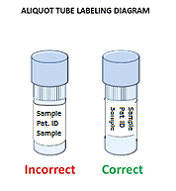Take a moment to ensure the label is **completely adhered** to each tube. It may be helpful to roll the tube between your fingers after applying the label.
* If there are any unused cryovials, **please do not send the empty cryovials to NCRAD**. These unused cryovials (ensure labels are removed) can be saved as part of a supplemental supply at your site or the cryovials can be disposed of per your site’s requirements.

## Filling Aliquot Tubes (Serum and Plasma)

In order to ensure that NCRAD receives a sufficient amount of sample for processing and storage, and to avoid cracking of the tubes prior to shipment, each cryovial should be filled to the assigned volume with the respective biological material after processing is completed (refer to detailed processing instructions for average yield per sample).

Over-filled tubes may burst once placed in the freezer, resulting in a loss of that sample. Aliquot the remaining biological material as the residual volume and ship to NCRAD. Essentially, all material should be shipped to NCRAD, ensuring maximum amount in as many cryovials as will allow after processing the sample. For example, if 3.6 ml of sample is obtained, you should fill 2 cryovials each with 1.5 ml, and one additional cryovial with the remaining 0.6 ml.

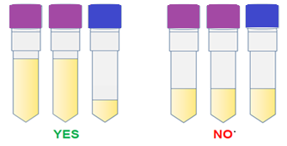

1.5 mll mml

**Note:** It is critical for the integrity of the samples that study staff note if an aliquot tube contains a residual volume (anything under 1.5 ml). Please highlight that the aliquot contains a small volume by utilizing the blue cryovial cap provided in each kit. Please record the specimen number and volume of the residual aliquot on the Biological Sample and Notification Form.

To assist in the preparation and aliquoting of samples, colored caps are used for the cryovials. The chart below summarizes the association between cap color and type of cryovial.

|  |  |
| --- | --- |
| **Cap Color** | **Sample Type** |
| Red Cap | Serum |
| Purple Cap | Plasma |
| Blue Cap | Residual (plasma and serum) |
| Clear Cap | Buffy Coat |
| Yellow Cap | Urine |

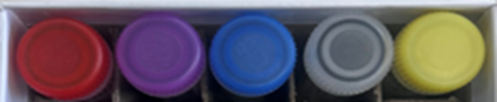

Red Cap (Serum)

Purple Cap (Plasma)

Blue Cap (Residual)

Yellow Cap (Urine)

Clear Cap (Buffy Coat)

## Pre-intervention Urine Collection Instructions

See [training video](https://www.youtube.com/watch?v=2rNMFt5WPlg) for urine collection.

* 1. Place completed ACE Patient ID Label and Collection and Aliquot **“URINE”** TubeLabel on the **C&S Preservative Tube** (gray top tube). Place pre-printed Aliquot “Urine” Tube Labels on the (3) 2.0 ml cryovial tubes with yellow caps.
  2. Give urine cup to patient and instruct on how to collect a clean, midstream urine sample:

**Midstream Clean-Catch Collection Instructions for Subjects**

**Preparation**:

1. Verify you have been provided soap towelettes and a urine collection cup.
2. Do not touch the inside of the cup.
3. Remove the cap and place the cup on the counter with the straw facing upwards.
4. Do not touch the inside of the cap or straw.
5. Do not remove the yellow label on the top of the cup.
6. Wash hands thoroughly with soap and water.

**Male Instructions:**

1. Cleanse the end of the penis with a soap towelette beginning at the urethral opening and work away from it (for uncircumcised males, the foreskin must first be retracted.
2. Void the first portion of the urine into the toilet.
3. While continuing to void, place the collection cup into the midstream to collect the urine specimen. Do not touch the inside or lip of the cup with the hands or any other part of the body. Void remained of urine into toilet.
4. Replace the cap on the cup touching only the outside surfaces of the cap and cup.
5. Screw the lid tightly.

**Female Instructions:**

1. Standing in a squatting position over the toilet, separate the folds of skin around the urinary opening. Cleanse the area around the opening with the first towelette. Repeat using the second towelette.
2. Void the first portion of the urine into the toilet.
3. While continuing to void, place the collection cup into the midstream to collect the urine specimen. Do not touch the inside or lip of the cup with the hands or any other part of the body. Void remainder of urine into the toilet.
4. Replace the cap on the cup touching only the outside surfaces of the cup.
5. Screw the lid on tightly.
   1. Apply clean gloves and receive urine sample as soon as possible after collection. Place sample on a clean paper towel.
   2. Peel back protective sticker on top of the urine cup to expose rubber covered cannula**.**

* 1. Push the **C&S Preservative Tube** (gray top tube) firmly down into the integrated transfer port so that the needle will pierce the stopper on the C&S Preservative Tube. Negative pressure will allow urine to flow into the tube.

1. Hold tube in position until flow stops.
2. Remove tube.
3. Invert the tube 8-10 times.
   1. Once the tube has mixed successfully with the preservative. Remove the gray rubber-tube stopper and using a 3ml pipette, dispense 1.5ml of urine into each yellow-top cryovial.
   2. Remove the urine by tilting the tube and placing the pipette tip along the lower side of the wall. Using a disposable pipette, transfer urine into the pre-labeled cryovials with the yellow caps. Aliquot 1.5 ml per cryovial (total vials = up to three with 1.5 mL). Be sure to only place urine in cryovials labeled with the “URINE” label and yellow caps.
   3. Place the labeled cryovials in a cryobox and place on dry ice. Transfer to -80°C Freezer when possible. Store all samples at -80°C until shipped to NCRAD on dry ice. Record time aliquots placed in freezer and storage temperature of the Freezer on the Urine Sample and Shipment Notification Form ([Appendix C](#_Appendix_C:_Biological)).
   4. Record date and time of urine sample collection and storage temperature of freezer on the Urine Sample and Shipment Notification Form ([Appendix C](#_Appendix_C:_Biological)). Include this sample form with the shipment to NCRAD.

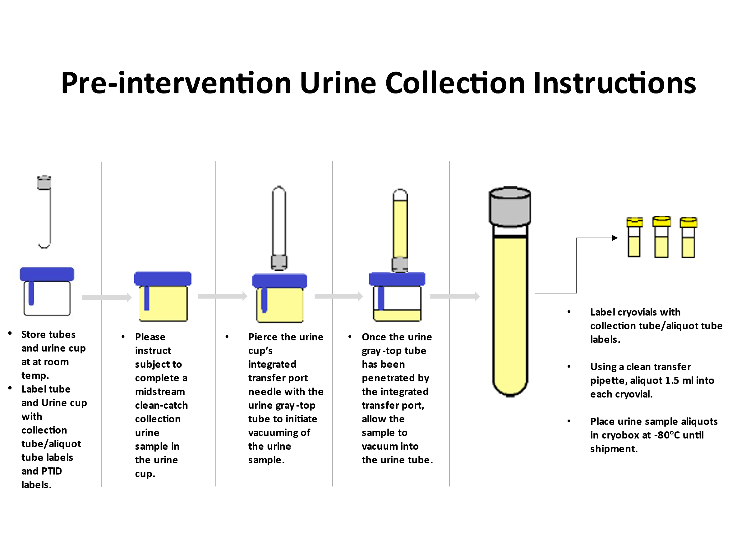

## Stool Collection Instructions

**Site personnel:**

* **Please label the stool tubes in reference to section** [**6.1**](#_Toc110942934)**.**
* **Please advise the following instructions to the subject and provide a** [**printout**](https://www.dnagenotek.com/row/pdf/PD-PR-00442.pdf) **of the instructions found on the NCRAD ACE Study website. Instructions will also be provided to the subject in the stool kit:**

1. Empty your bladder before beginning the collection. Collect fecal sample free of urine and toilet water. Toilet paper or tissues may be required.
2. While holding the yellow tube top, unscrew ONLY the purple cap from the kit and set aside for later use.

**\*IMPORTANT:**

* Do NOT remove the yellow tube top.
* Do NOT spill the stabilizing liquid in the tube.

1. Using a spatula, collect a small amount of fecal sample.

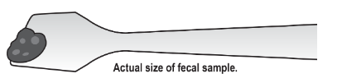

1. Transfer the fecal sample into the yellow tube top. Repeat until the sample fills the yellow tube top.

**\*IMPORTANT:**

* Do NOT push sample into the tube.

1. Scrape horizontally across the tube top to level the sample and remove any excess. Wipe exterior of tube and top with toilet paper or tissue as needed.
2. Pick up the purple cap with the solid end facing down and screw onto the yellow tube top until tightly closed.

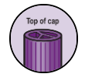

1. Shake the sealed tube as hard and fast as possible in a back-and-forth motion for a minimum of 30 seconds.

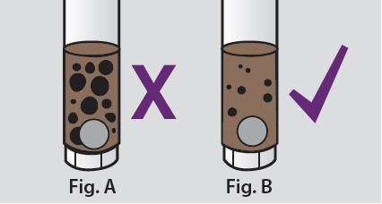

**\*\*Please advise and emphasize to the subject that the stool sample contents should reflect Figure B. If the sample arrives not reflecting Figure B then we will notify the site to recollect.**

1. The fecal sample will be mixed with the stabilizing liquid in the tube; not all particles will dissolve.
2. Place spatula in original packaging or wrap in toilet paper and discard in garbage.
3. Once the samples have been collected, please instruct the subject to place the samples in a biohazard bag and seal it.
4. Instruct the subject to record the **date and time** of collection on the Stool Sample Form.
5. Advise the subject to properly place samples in the biohazard bag into the provided shipping box along with the Stool Sample Form on top of the samples. Samples may be kept ambient, and do not need to be refrigerated or frozen.

**\*\*Site personnel will need to pre-apply the UN3373 Biological Substance Category B label, the USPS Express Shipping Label and the USPS postage sticker on the shipping box provided to the subject and complete the first portion of Stool Sample Form.**

1. Finally, please instruct the subject to place the package out for a USPS pickup – whether that be in a mailbox, or a local USPS pickup location.

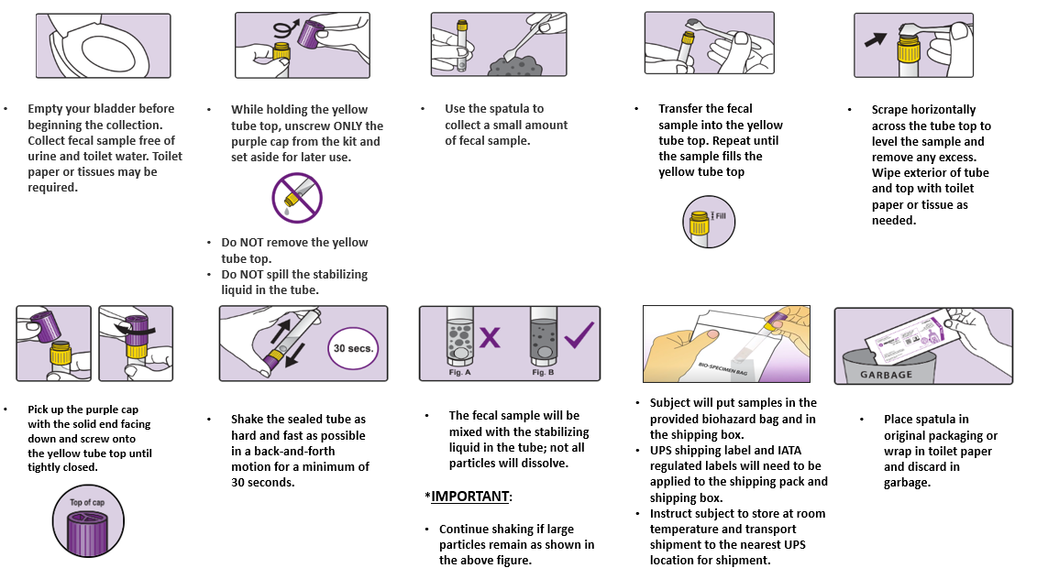**At-Home Stool Collection Instructions**

## Whole Blood Collection with 10 ml Serum (Red-Top) Tube for Serum

1. Set centrifuge 4°C to pre-chill before use.
2. Place completed ACE Patient ID Label and Collection **“SERUM”** TubeLabels on the Plain Red-Top Serum Blood Collection Tube. Place pre-printed Aliquot “**SERUM**” Tube Labels on the three (3) 2.0 ml cryovial tubes with red caps and one (1) 2.0 ml cryovial with blue cap (if necessary, for residual).
3. Using a blood collection set and a holder, collect blood into **Plain Red-Top Serum Blood Collection Tubes (10 ml)** using your institution's recommended procedure for standard venipuncture technique.

The following techniques shall be used to prevent possible backflow:

a. Place donor's arm in a downward position.

b. Hold tube in a vertical position, below the donor’s arm during blood collection.

c. Release tourniquet as soon as blood starts to flow into tube.

d. Make sure tube additives do not touch the stopper or the end of the needle during venipuncture.

1. Allow at least 10 seconds for a complete blood draw to take place in each tube. **Ensure that the blood has stopped flowing into each tube before removing the tube from the holder.** The tube with its vacuum is designed to draw 5 ml of blood into the tube.
   1. If complications arise during the blood draw, please note the difficulties on the ‘Biological Sample and Shipment Notification Form’. Do not attempt to draw an additional Serum tube at this time. Process blood obtained in existing Serum tube.
2. **CRITICAL STEP:** Immediately after blood collection, gently invert/mix (180 degree turns) each tube 5 times.
3. **CRITICAL STEP:** Allow blood to clot at room temperature by placing it upright in a vertical position in a tube rack for 30 minutes. If after 30 minutes the sample is not clotted, allow it to set up to 60 minutes to clot. Serum samples need to be spun, aliquoted, and placed in the freezer within 2 hours from the time of collection.
4. After clotting, centrifuge the collection tube for 10 minutes at 2000 x g at 4°C. **It is critical that the tube be centrifuged at the appropriate speed to ensure proper serum separation** (see worksheet in [Appendix A](#AppendixA) to calculate RPM)
5. Equivalent rpm for spin at 2000 x g
6. While centrifuging, remember to record all times, temperatures and spin rates on the Biological Sample and Shipment Notification Form [Appendix B](#AppendixB).
7. Serum samples need to be spun, aliquoted, and placed in the freezer within 2 hours from the time of collection.
8. Record time aliquoted on the Biological Sample Shipment and Notification Form.
9. Remove the serum by tilting the tube and placing the pipette tip along the lower side of the wall. Using a disposable pipette, transfer serum into the pre-labeled cryovials with the red caps. Aliquot 1.5 ml per cryovial (total vials = up to three with 1.5 mL and one residual with <1.5 ml). Be sure to only place **serum** in cryovials labeled with the “SERUM” label and red caps. If there is extra serum left, use 1 extra blue-cap cryovial provided for another <1.5 ml aliquot of serum and label as appropriate. **If a residual aliquot is created, document the sample number and volume on the Blood Sample and Shipment Notification Form.**

1. 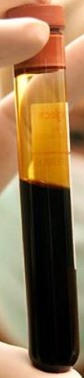Place the labeled cryovials in a cryobox and place on dry ice. Transfer to **-80°C Freezer when possible**. Store all samples at **-80°C until shipped** to NCRAD on dry ice. Record time aliquots placed in freezer and storage temperature of the

Serum Aliquots: up to 4 (1.5ml each) red cap cryovials possible or 3 red capped cryovials (1.5ml) and one blue capped residual (<1.5ml)

RBC, WBC & Platelet Clot

Serum

Freezer on the Biological Shipment Notification form.

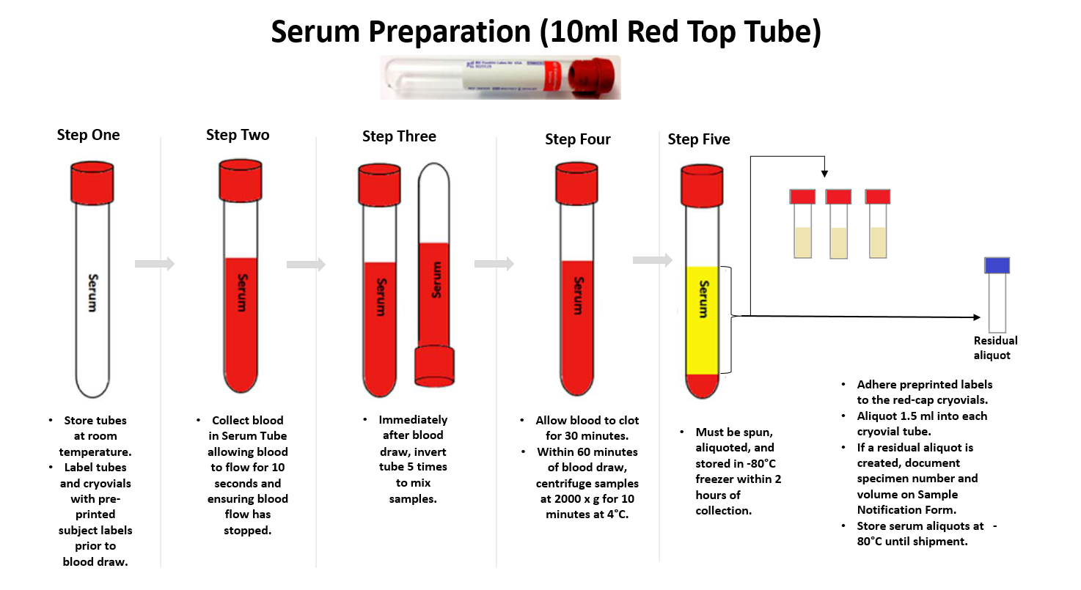

## Whole Blood Collection with EDTA (Purple-Top) Blood Collection Tube (10 ml) for Plasma and Buffy Coat (2 x 10ml)

1. Set centrifuge to 4°C to pre-chill before use.
2. Place completed ACE Patient ID Label and pre-printed “**PLASMA**” Collection Tube and Aliquot Label on the purple-top EDTA tubes. Place pre-printed “**PLASMA**” Cryovial Labels on the six (6) 2.0 ml cryovials with purple caps and one (1) 2.0 ml cryovial with blue cap (if necessary, for residual). Place pre-printed “**BUFFY COAT**” Cryovial Label on the two (2) 2.0 ml cryovials with clear caps.
3. Using a blood collection set and a holder, collect blood into the **EDTA (Purple-Top) Blood Collection Tubes (10 ml)** using your institution's recommended procedure for standard venipuncture technique.

**The following techniques shall be used to prevent possible backflow:**

a. Place participant's arm in a downward position.

b. Hold tube in a vertical position, below the participant’s arm during blood collection.

c. Release tourniquet as soon as blood starts to flow into tube.

d. Make sure tube additives do not touch stopper or end of the needle during venipuncture.

1. Allow at least 10 seconds for a complete blood draw to take place in each tube. **Ensure that the blood has stopped flowing into the tube before removing the tube from the holder.** The tube with its vacuum is designed to draw 10 ml of blood into the tube.

If complications arise during the blood draw, please note the difficulties on the ‘Blood Sample and Shipment Notification Form’. Do not attempt to draw an additional EDTA tube at this time. Process blood obtained in existing EDTA tube.

1. **CRITICAL STEP: Immediately after blood collection, gently invert/mix (180 degree turns) the EDTA tubes 8-10 times.**
2. **CRITICAL STEP: Immediately after inverting the EDTA tubes, place them on wet ice until centrifugation begins.**
3. Centrifuge balanced tubes for 10 minutes at 2000 x g and 4°C. **It is critical that the tubes be centrifuged at the appropriate speed and temperature to ensure proper plasma separation (see worksheet in** [**Appendix A**](#AppendixA) **to calculate RPM.)**
4. Equivalent rpm for spin at 2000 x g
5. While centrifuging, remember to record all times, temperatures and spin rates on the Biological Sample and Shipment Notification Form.
6. Record original volume drawn for each tube in spaces provided on the Biological Sample Shipment and Notification Form.
7. Plasma samples need to be spun, aliquoted, and placed in the freezer within 2 hours from the time of collection.
8. Record time aliquoted on the Biological Sample Shipment and Notification Form.
9. Remove the plasma, being careful not to agitate the packed red blood cells at the bottom of the tube. Tilt the tube and place a disposable pipette tip along the lower side of the wall without touching the pellet (buffy coat) so that plasma is not contaminated (see below). Transfer plasma from both EDTA tubes into the 15 ml conical tube and gently invert 3 times.
10. Aliquot 1.5 ml per cryovial (total vials = up to 7 with 1.5 ml each). Each EDTA tube should yield, on average, 4-5 ml of plasma. Be sure to only place **plasma** in cryovials with purple caps and labeled with “PLASMA” labels**.** Take caution not to disturb the red blood cells at the bottom of the tube. If there is extra plasma left, use 1 blue-capped cryovial with “PLASMA” label for another <1.5 ml aliquot of plasma. **If a residual aliquot (<1.5 ml) is created, document the sample number and volume on the Blood Sample and Shipment Notification Form (**[**Appendix B**](#AppendixB)**).**

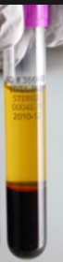

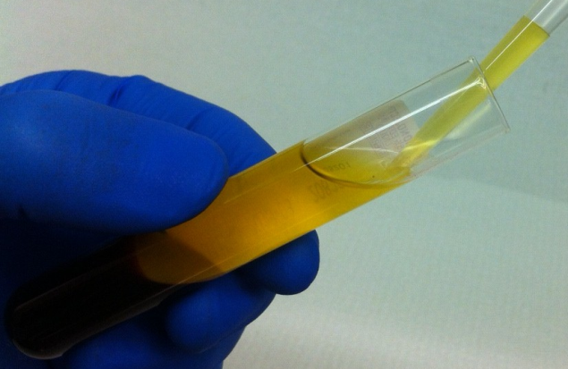 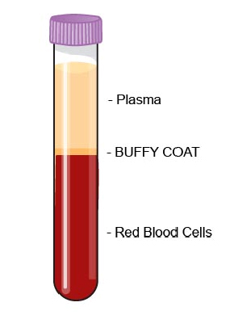 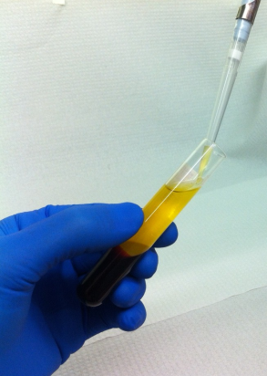

**NOTE: When pipetting plasma from the plasma tube into the cryovials, be very careful to pipette the plasma top layer only, leaving the buffy coat and the red blood cell layers untouched.**

1. Place the labeled cryovials in a cryobox and place on dry ice. Transfer to **-80°C Freezer when possible**. Store all samples at **-80°C until shipped** to NCRAD on dry ice. Record time aliquots placed in freezer and storage temperature of the freezer on Blood Sample Shipment and Notification Form.
2. After plasma has been removed from the EDTA (Purple-Top) Blood Collection Tubes (10 ml), aliquot buffy coat layer (in the top layer of cells, the buffy coat is mixed with RBCs – see following figure) into labeled cryovials with clear caps using a pipette. **Aliquot each buffy coat into a separate cryovial.** The buffy coat aliquot is expected to have a reddish color from the RBCs. Be sure to place buffy coat into cryovials with the clear caps and “BUFFY COAT” label.

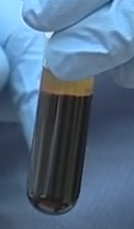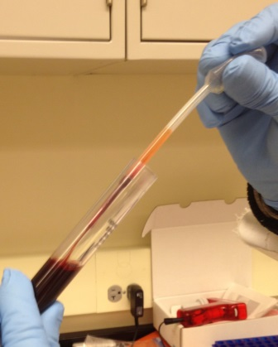

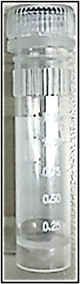

Buffy Coat layer (mixed with RBCs)

Buffy Coat Aliquot

(Please use CLEAR CAP) cryovial)

1. Dispose of tube with red blood cell pellet according to your site’s guidelines for disposing of biomedical waste.
2. Place the labeled cryovials in the 25-slot cryovial box and place on dry ice. Transfer to **-80°C Freezer when possible**. Store all samples at **-80°C until shipped** to NCRAD on dry ice.

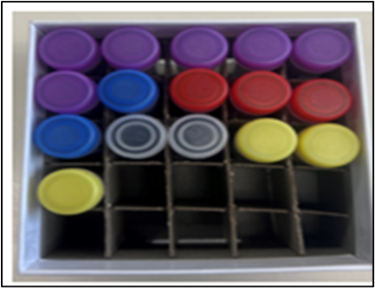

**Plasma (up to 7 possible), Buffy Coat (2), Serum (up to 4 possible) and Urine (3) Aliquots**

**Plasma and Buffy Coat Preparation EDTA Purple-Top Tube (2 x 10 ml)**

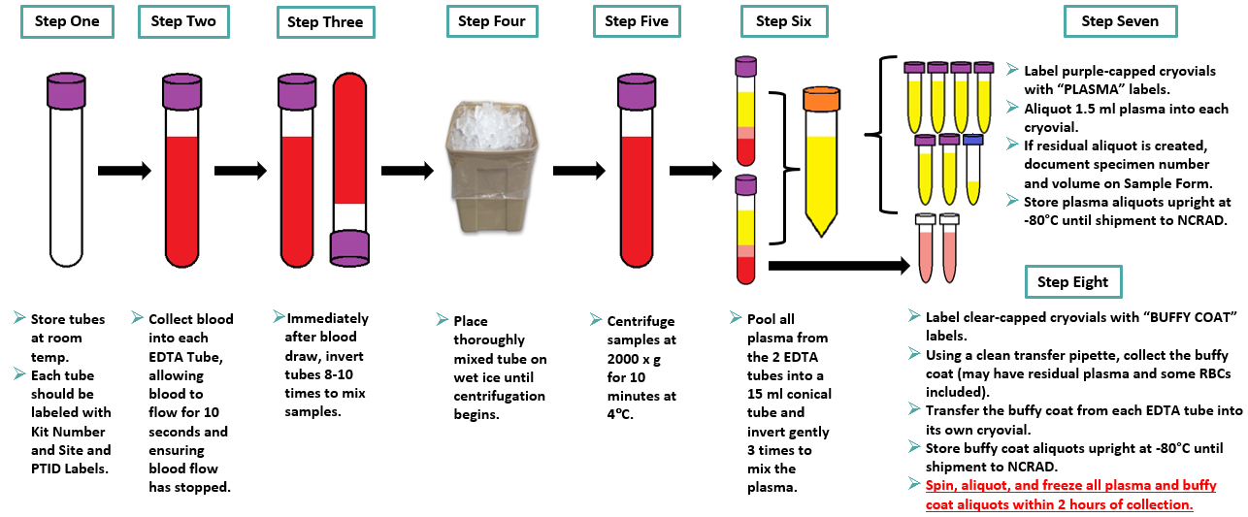

# 7.0 Incomplete or Difficult Blood Draws

**\*\*\*Important Note\*\*\***

**If challenges arise during the blood draw process, it is advised that the phlebotomist discontinue the draw. Attempt to process and submit any blood-based specimens that have already been collected to NCRAD.**

Situations may arise that prevent study coordinators from obtaining the total amount scheduled for biofluids. In these situations, please follow the below steps:

1. If the biofluids at a scheduled visit **are partially** collected:
   1. Attempt to process and submit any samples that were able to be collected during the visit.
   2. Document difficulties on the ‘Biological Sample and Shipment Notification Form’ prior to submission to NCRAD.
      1. Indicate blood draw difficulties at the bottom of the ‘Biological Sample and Shipment Notification Form’ within the “Notes” section.
      2. Complete the ‘Biological Sample and Shipment Notification Form’ with tube volume approximations and number of aliquots created.

|  |  |  |  |  |
| --- | --- | --- | --- | --- |
| **Draw Tube Order** | **Sample Type** | **Tube Type** | **Tubes to NCRAD** | **Ship** |
| **1** | **Urine** | URINE: 2.0 ml cryovials with yellow cap | 3 | Frozen |
| **2** | **Whole blood for isolation for serum** | SERUM: 2.0 ml cryovials with red cap (residual volume placed in 2.0 ml cryovial with blue cap) | Up to 4 | Frozen |
| **3** | **Whole blood for isolation of plasma & buffy coat (for DNA extraction)** | PLASMA:  2.0 ml cryovials with purple cap (residual volume placed in 2.0 ml cryovial with blue cap) | Up to 7 | Frozen |
| BUFFY COAT:  2.0 ml cryovial | 2 | Frozen |

* 1. Contact a NCRAD coordinator and alert them of the challenging blood draw.

# Packaging and Shipping Instructions

**ALL** study personnel responsible for shipping should be certified in biofluid shipping (i.e. IATA certification). If not available at your institution, please contact NCRAD with questions and information regarding resources.

## Ambient Packaging and Shipping Instructions

Ambient stool sample shipments should be considered as Category B UN3373 and as such must be compliant with the IATA Packing Instructions 650. Due to the level of reagent in the stool collection tubes an Excepted Quantity label provided. See the Latest Edition of the IATA Regulations for complete documentation.

Triple packaging consists of a primary receptacle(s), a secondary packaging, and a rigid outer packaging. The primary receptacles must be packed in secondary packaging in such a way that, under normal conditions of transport, they cannot break, be punctured or leak their contents into the secondary packaging. Secondary packaging must be secured in outer packaging with suitable cushioning material. Any leakage of the contents must not compromise the integrity of the cushioning material or of the outer packaging.

**\*\*\* Ambient Shipping Packing and Labeling Guidelines \*\*\***

* The primary receptacle (Stool collection kit) must be leak proof and must not contain more than 10 ml total.
* The secondary packaging (small biohazard bag) must be leak proof.
* Absorbent material will be placed in the secondary receptacle (small biohazard bag). The absorbent material should be of sufficient quantity in order to absorb the entire contents of the specimens being shipped.
* A shipping manifest of specimens being shipped must be included between the secondary and outer packaging.
* The outer shipping container will pre-display the following labels:
  + Sender’s name and address (pre-populated on UPS shipping label)
  + Recipient’s name and address (pre-populated on UPS shipping label)
  + Responsible Person (pre-populated on UPS shipping label)
  + The words “Biological Substance, Category B”
  + UN3373

**Remember to complete the Stool Sample and Shipment Notification Form** [**Appendix D**](#_Appendix_D:_Stool)**- include a copy in your shipment.**

### 8.1.1 NCRAD Packaging Instructions—Stool Ambient Shipments

**\*\*Site Personnel instructions:**

1. Notify NCRAD of shipment by emailing NCRAD coordinators at: [alzstudy@iu.edu](mailto:alzstudy@iu.edu)
   1. Complete and attach the Stool Sample and Shipment Notification Form to the email. (See [Appendix D](#_Appendix_D:_Stool))
   2. Complete the subject’s gender, YOB, and Patient ID information and place the kit number label on a copy of the Stool Sample and Shipment Notification Form and provide the copy to the subject to accurately record time and date later. (See [Appendix D](#_Appendix_D:_Stool))
   3. Apply the required labels to the ambient shipping box.
      1. Apply the Biological Substance Category B UN3373 sticker to side of the box.

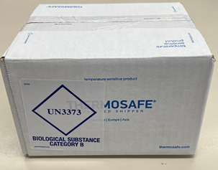

Side of the box

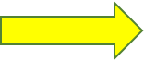

Top of the box

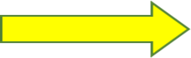

* + 1. Apply the NCRAD USPS Express shipping label (1) and the USPS postage sticker (2) to the bottom of the ambient shipper for the subject prior to giving to the participant. **The USPS postage sticker must be placed above the barcode (3) and must not be covered it up.**

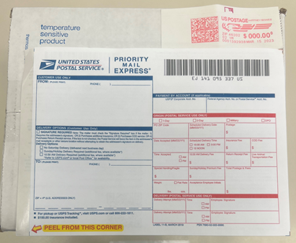

**\*\*Subject At-Home Instructions**

1. After successfully collecting the stool samples please instruct the subject to **accurately** record the date and time the stool samples were collected on the Stool Sample and Shipment Notification Form. (See [Appendix D](#_Appendix_D:_Stool))
2. Once the Stool Sample and Shipment Notification Form has been accurately recorded, instruct the subject to place the two stool collection tubes within the provided biohazard bag with absorbent sheet.

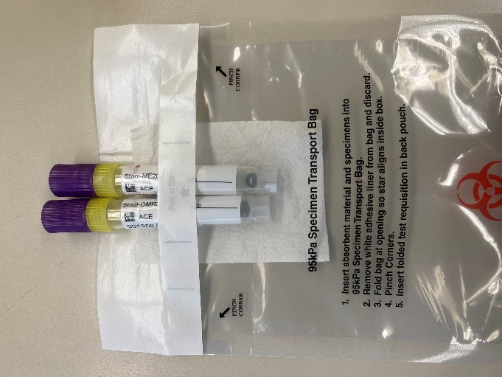

**Stool Collection Tubes**

**Absorbent Pad**

**Biohazard Bag**

1. Instruct the subject to remove as much air as possible from the plastic biohazard bag and seal the bag according to the directions printed on the bag.
2. Next please instruct the subject to place the biohazard bag containing the stool collection tubes, in the provided ambient shipping box (IATA regulated Category B label should be applied by site personnel).
3. After the biohazard bag has been securely sealed and placed inside the ambient shipping box’s Styrofoam container (cold pack included), please instruct the subject to place the Styrofoam box-top on top of the Styrofoam container containing to secure the samples. Lastly, instruct the subject to fold and place the Stool Sample and Shipment Notification Form ([Appendix D](#_Appendix_D:_Stool)) on top of the secured Styrofoam container containing the stool collection tubes, fold the box tops and apply the Uline tape strip to seal the ambient shipper.
4. Instruct the subject to please place the ambient shipping box in the designated area their daily mail is picked up to ensure that the package is

picked up and received by NCRAD.

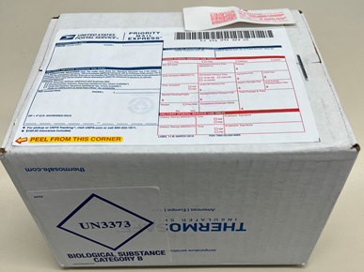

## 

## Frozen Packaging Information

The most important issue for shipping is to maintain the temperature of the samples. The frozen samples must never thaw; not even the outside of the tubes should be allowed to defrost. This is best accomplished by making sure the Styrofoam container is filled completely with pelleted dry ice.

|  |
| --- |
| **IMPORTANT!** |
| **FROZEN SAMPLES MUST BE SHIPPED**  **MONDAY-WEDNESDAY ONLY!** |

Specimens being shipped to NCRAD should be considered as Category B UN3373 specimens and as such must be tripled packaged and compliant with IATA Packing Instructions 650. *See the Latest Edition of the IATA Regulations for complete documentation.*

**\*\*\* Packing and Labeling Guidelines \*\*\***

* The primary receptacle (frozen cryovials) must be leak proof and must not contain more than 1L total.
* The secondary packaging (biohazard bag) must be leak proof and if multiple blood tubes are placed in a single secondary packaging, they must be either individually wrapped or separated to prevent direct contact with adjacent blood tubes.
* Absorbent material must be placed between the primary receptacle and the secondary packaging. The absorbent material should be of sufficient quantity in order to absorb the entire contents of the specimens being shipped. Examples of absorbent material are paper towels, absorbent pads, cotton balls, or cellulose wadding.
* A shipping manifest of specimens being shipped must be included between the secondary and outer packaging.
* The outer shipping container must display the
* following labels:
  + Sender’s name and address
  + Recipient’s name and address
  + Responsible Person
  + The words “Biological Substance, Category B”
  + UN3373
  + UPS Dry Ice label and net weight of dry ice contained

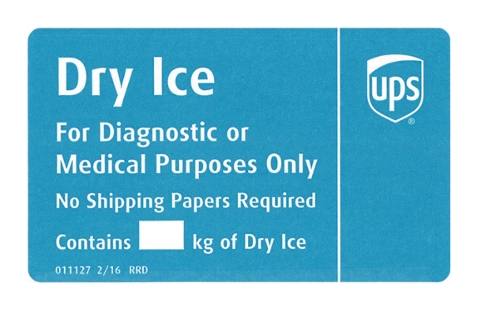

Triple packaging consists of a primary receptacle(s), a secondary packaging, and a rigid outer packaging. The primary receptacles must be packed in secondary packaging in such a way that, under normal conditions of transport, they cannot break, be punctured, or leak their contents into the secondary packaging. Secondary packaging must be secured in outer packaging with suitable cushioning material. Any leakage of the contents must not compromise the integrity of the cushioning material or of the outer packaging.

### Frozen Packaging Instructions

1. Notify NCRAD of shipment by emailing NCRAD coordinators at: [alzstudy@iu.edu](mailto:alzstudy@iu.edu). Attach the following to the email:
2. The completed Blood Sample and Shipment Notification Form to the email notification and Urine Sample and Shipment Notification Form. (See [Appendix B](#AppendixB) and [Appendix C](#_Appendix_C:_Biological) for an example of the NCRAD sample form)
3. If email is unavailable, please call NCRAD (800-526-2839) and do not ship until you have contacted and notified NCRAD coordinators about the shipment in advance.
4. Place all frozen labeled aliquots of plasma and buffy coat aliquots from the same subject in the cryovial cryobox.
   * 1. Each 25-slot cryobox will hold approximately 13 cryovial samples. Place serum, plasma, buffy coat and urine within one cryobox (4 serum, 7 plasma, 2 buffy coat, 3 urine) per participant blood draw (see below).

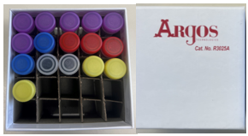

One cryobox containing serum, plasma, residuals, buffy coat, and urine aliquots.

* + 1. Cryoboxes should contain all of the specimens from the same patient, per time point.
    2. **Batch shipping should be performed every (3) three months or when specimens from 5 participants accumulates, whichever is sooner.**

1. Label the outside of the cryoboxes with the appropriate kit number label(s). Place serum, plasma, buffy, and urine aliquots within one cryobox and place within a biohazard bag. The biohazard bags are large enough to contain one cryobox from one subject’s visit.
2. Place the cardboard cryobox in the clear plastic biohazard bag (do NOT remove the absorbent material found in the bag). Seal biohazard bag according to the instructions on the bag.

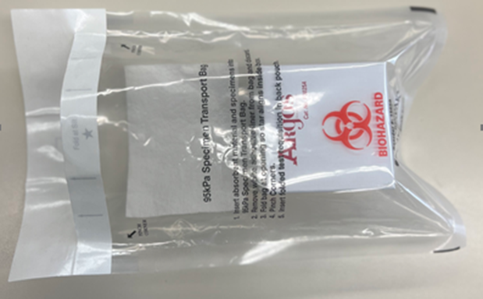

Place kit number label(s) on cryobox

1. Place approximately 2-3 inches of dry ice in the bottom of the Styrofoam shipping container.
2. Place the biohazard bag into the provided Styrofoam-lined shipping container on top of the dry ice. Please ensure that cryoboxes are placed so the cryovials are upright in the shipping container (as pictured below).
3. Fully cover the cryoboxes and urine collection tube with approximately 2 inches of dry ice.
4. The inner Styrofoam shipping container must contain approximately 45 lbs (or 21kg) of dry ice. The dry ice should entirely fill the inner box to ensure the frozen state of the specimens.

Full Shipping Container with Batched Samples and Dry Ice

**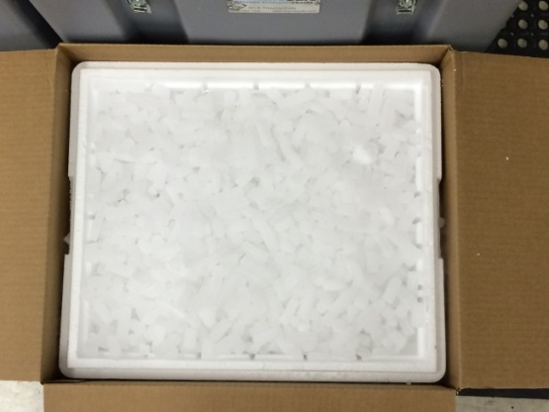**

1. Replace the lid on the Styrofoam carton. Place the completed Blood Sample and Shipment Notification Form and Urine Sample and Shipment Notification Form in the package on top of the Styrofoam lid for each patient specimen, and close and seal the outer cardboard shipping carton with packing tape.
2. Complete the UPS Dry Ice Label.
   1. Net weight of dry ice in kg (must match amount on the airbill)
   2. Do not cover any part of this label with other stickers, including pre-printed address labels.
3. Apply all provided warning labels and the pre-printed UPS return airbill to the outside of package, taking care not to overlap labels.

|  |
| --- |
| **IMPORTANT!** |
| **Complete the UPS Dry Ice label or UPS may reject or return your package.** |

1. Hold packaged samples in -80°C freezer until time of UPS pick-up/drop-off.
2. Specimens should be sent to the following address via **UPS Next Day Air**. Frozen shipments should be sent **Monday through Wednesday** to avoid shipping delays on Thursday or Friday. UPS does not replenish dry ice if shipments are delayed or held over during the weekend.

ACE at NCRAD

Indiana University School of Medicine

351 West 10th Street

TK-217

Indianapolis, IN 46202  
Phone: 1-800-526-2839

1. Use UPS tracking to ensure the delivery occurs as scheduled and is received by NCRAD. Please notify NCRAD by email ([alzstudy@iu.edu](mailto:alzstudy@iu.edu)) that a shipment has been sent and include the UPS tracking number in your email.

**\*\*\*Important Note\*\*\***

**For frozen shipments, include no more than five cryovial boxes and five urine tubes (separated by patient within 5 biohazard bags) per shipping container in order to have room for a sufficient amount of dry ice to keep samples frozen up to 24 hours.**

**The labeled, processed, aliquoted, and frozen cryovials of serum, plasma and buffy coat will be shipped to NCRAD as outlined above.**

**Ship all frozen samples Monday - Wednesday ONLY!**

**BE AWARE OF HOLIDAYS!!**

BE AWARE OF INCLEMENT WEATHER THAT MAY DELAY SHIPMENT/DELIVERY OF SAMPLES

**Remember to complete the Blood Sample and Shipment Notification Form and Urine Sample and Shipment Notification Form,** [**Appendix B**](#_Appendix_B:_Biological) **and** [**Appendix C**](#PPMI_Saliva_Sample_Form)**- include a copy in your shipment AND notify the NCRAD Study Coordinator by email at** [**alzstudy@iu.edu**](mailto:alzstudy@iu.edu) **(include UPS tracking number in email) IN ADVANCE to confirm the shipment.**

## Frozen Shipping Instructions

1. Log into the ShipExec Thin Client at kits.iu.edu/UPS.
   1. If a new user or contact needs access, please reach out to your study contact for access.
2. C:\Users\wilmesk\AppData\Local\Temp\msohtmlclip1\02\clip_image001.pngClick “Shipping” at the top of the page and select “Shipping and Rating”
   1. 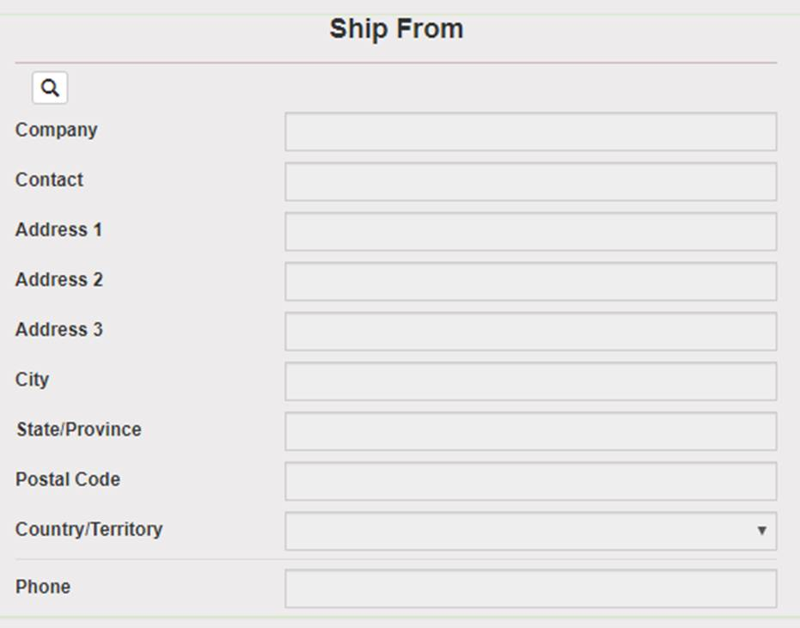Select your study from the “Study Group” drop down on the right side of the main screen. Choosing your study will automatically filter the address book to only addresses within your study.
   2. Click on the magnifying glass icon in the “Ship From” section to search for your shipping address.
      1. Search by Company (site), Contact (name), or Address 1 (first line of your site’s street address). Click Search.
      2. Click Select to the left of the correct contact information.
   3. Verify that both the shipping information AND study reference are correct for this shipment.
   4. If wrong study contact or study reference, click Reset in the bottom right of the screen to research for the correct information.
3. Enter Package Information
   1. Frozen shipments
      1. Enter the total weight of your package in the “Weight” field.
      2. Enter the dry ice weight in the “Dry Ice Weight” field.
      3. If the “Dry Ice Weight” field is higher than the “Weight” field, you will receive an error message after clicking “Ship” and need to reenter these values.
   2. Click Ship in the bottom right of the page when complete.
4. If your site does not already have a daily UPS pickup, you will need to schedule one
   1. Click the blue Pickup Request button. Enter the earliest pickup time and latest pickup time in 24-hr format.
   2. Give a name & phone number of someone who the UPS driver can call if having issues finding the package.
   3. Give the Floor and Room Number (if needed) to be as descriptive as possible where this package needs to be picked up from. Click Save.
5. Print the airbill that is automatically downloaded.
   1. To reprint airbill, click History at the top left of the page.
   2. Click Detailed Report from the dropdown menu on the right side of the page.
   3. Enter tracking number if known. Otherwise, search by ship date. Click Search.
   4. Click print icon on right side of the tracking number line.
6. Fold airbill and place inside plastic UPS sleeve.
7. Peel the back off of the UPS sleeve, and stick the sleeve to the package.
8. A UPS Pickup is automatically scheduled at the address you are shipping from, and the pickup is charged to NCRAD.
   1. If shipment occurs too late in the day for an automatic UPS pickup, you will receive an email stating that the pickup could not be scheduled, and you will need to make other arrangements.

# Data Queries and Sample Reconciliation

The sample forms must be completed on the day that samples are collected since they capture information related to the details of the sample collection and processing. These forms include information that will be used to reconcile sample collection and receipt, as well as information essential to future analyses.

Data queries or discrepancies with samples shipped and received at NCRAD may result from:

* Missing samples
* Incorrect samples collected and shipped
* Damaged or incorrectly prepared samples
* Unlabeled samples, samples labeled with incomplete information, or mislabeled samples
* Discrepant information documented on the Sample and Shipment Notification Forms and logged at NCRAD compared to information entered into the study database.
* Samples that are frozen and stored longer than one quarter at the site
* Use of an incorrect Sample and Shipment Notification Forms

# Appendices List

[Appendix A: Rate of Centrifugation Worksheet](#AppendixA)

[Appendix B: Blood Sample and Shipment Notification Form](#AppendixB)

[Appendix C: Urine Sample and Shipment Notification From](#_Appendix_C:_Biological)

[Appendix D: Stool Sample and Shipment Notification Form](#_Appendix_D:_Stool)

## Appendix A: Rate of Centrifuge Worksheet

Please complete and return this form by email to the NCRAD Study Team if you have any questions regarding sample processing. The correct RPM will be sent back to you.

**Submitter Information**

|  |  |
| --- | --- |
| **Name:** | **Site:** |
| **Submitter e-mail:** | |

**Centrifuge Information**

Please answer the following questions about your centrifuge.

**Centrifuge Type**

Fixed Angle Rotor: ☐ Swing Bucket Rotor: ☐

**Radius of Rotation (mm):**

Determine the centrifuge’s radius of rotation (in mm) by measuring distance from the center of the centrifuge spindle to the bottom of the device when inserted into the rotor (if measuring a swing bucket rotor, measure to the middle of the bucket).

**Calculating RPM from G-Force:**

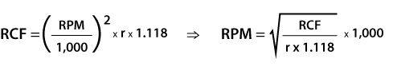

RCF = Relative Centrifugal Force (G-Force)

RPM = Rotational Speed (revolutions per minute)

R= Centrifugal radius in mm = distance from the center of the turning axis to the bottom of centrifuge

Comments:

**Please send this form to NCRAD Study Coordinator at** [**alzstudy@iu.edu**](mailto:alzstudy@iu.edu)

## Appendix B: Blood Sample and Shipment Notification Form

*Please email the form on or prior to the date of shipment.*

|  |
| --- |
| To: Diont’e Keys Email: [alzstudy@iu.edu](mailto:alzstudy@iu.edu) Phone: 1-800-526-2839 |
| *General Information:* **UPS tracking #: \_\_\_\_\_\_\_\_\_\_\_\_\_\_\_\_\_\_\_\_\_\_\_\_\_\_\_\_\_\_\_\_\_\_\_\_\_\_\_\_\_\_\_\_\_\_\_\_\_**  From:\_\_\_\_\_\_\_\_\_\_\_\_\_\_\_\_\_\_\_\_\_\_\_\_\_\_\_\_\_\_\_\_\_\_\_\_\_ Date: \_\_\_\_\_\_\_\_\_\_\_\_\_\_\_\_\_\_\_\_\_\_\_\_\_\_\_\_\_\_\_\_\_\_\_\_\_\_\_\_\_\_\_\_  Phone: \_\_\_\_\_\_\_\_\_\_\_\_\_\_\_\_\_\_\_\_\_\_\_\_\_\_\_\_\_\_\_\_\_\_\_\_\_ Email: \_\_\_\_\_\_\_\_\_\_\_\_\_\_\_\_\_\_\_\_\_\_\_\_\_\_\_\_\_\_\_\_\_\_\_\_\_\_\_\_\_\_\_ |
| **Study:** ACE **Visit:** BL M12 M24  KIT BARCODE  **Site ID:** \_\_\_\_\_\_\_\_\_\_\_\_\_\_\_\_ **ACE** **Patient ID #: \_\_\_\_\_\_\_\_\_\_\_\_\_\_\_\_**  **Sex:** M F **Year of Birth: \_\_\_\_\_\_\_\_\_\_** |
| *Blood Collection:*   |  |  | | --- | --- | | Date Drawn: [MM/DD/YY] | Time of Draw: [HHMM] | | Date subject last ate: [MM/DD/YY] | Time subject last ate: [HHMM] | |
| *Blood Processing:*   |  |  |  |  | | --- | --- | --- | --- | | **Serum (Red-top) Tube (10 mL)** | | **Plasma & Buffy Coat (Purple-top) Tube (10 mL)** | | | Time spin started: | \_\_\_\_\_\_\_\_\_\_ [HHMM] | Time spin started: | \_\_\_\_\_\_\_\_\_ [HHMM] | | Duration of centrifuge: | \_\_\_\_\_\_\_\_\_\_Minutes | Duration of centrifuge: | \_\_\_\_\_\_\_\_\_ Minutes | | Temp of Centrifuge: | \_\_\_\_\_\_\_\_\_\_ °C | Temp of Centrifuge: | \_\_\_\_\_\_\_\_\_ °C | | Rate of centrifuge: | \_\_\_\_\_\_\_\_\_\_ x g | Rate of centrifuge: | \_\_\_\_\_\_\_\_\_ x g | | Original volume drawn  (1 x 10 mL tube): | \_\_\_\_\_\_\_\_\_\_ mL | Original volume of EDTA #1: | \_\_\_\_\_\_\_\_\_ mL | | Original volume of EDTA #2: | \_\_\_\_\_\_\_\_\_ mL | | Time aliquoted: | \_\_\_\_\_\_\_\_\_\_ [HHMM] | EDTA #1 specimen number  (Last 4 digits): | \_\_\_\_\_\_\_\_\_ | | Number of 1.5 mL serum aliquots created (red cap): | \_\_\_\_\_\_\_\_\_\_ | EDTA #2 specimen number  (Last 4 digits): | \_\_\_\_\_\_\_\_\_ | | If applicable, volume of residual serum aliquot (<1.5 mL in blue cap): | \_\_\_\_\_\_\_\_\_\_ mL | Time aliquoted: | \_\_\_\_\_\_\_\_\_ [HHMM] | | If applicable, last four digits of residual serum aliquot: | \_\_\_\_\_\_\_\_\_\_ | Number of 1.5 mL plasma aliquots created (purple cap): | \_\_\_\_\_\_\_\_\_ | | Time aliquots placed in freezer: | \_\_\_\_\_\_\_\_\_\_[HHMM] | If applicable, volume of residual plasma aliquot (<1.5 mL in blue cap): | \_\_\_\_\_\_\_\_\_ mL | | Storage temperature in freezer: | \_\_\_\_\_\_\_\_\_\_°C | If applicable, last four digits of residual plasma aliquot: | \_\_\_\_\_\_\_\_\_ | |  | | Time aliquots placed in freezer: | \_\_\_\_\_\_\_\_\_ [HHMM] | | Storage temperature in freezer: | \_\_\_\_\_\_\_\_\_ °C | | Buffy coat #1 volume(clear cap, one per 10 mL EDTA tube) | \_\_\_\_\_\_\_\_\_ mL | | Buffy coat #2 volume(clear cap, one per 10 mL EDTA tube) | \_\_\_\_\_\_\_\_\_ mL | | *Notes:* | | | | |

## Appendix C: Urine Sample and Shipment Notification Form

*Please email the form on or prior to the date of shipment.*

|  |
| --- |
| To: Diont’e Keys Email: [alzstudy@iu.edu](mailto:alzstudy@iu.edu) Phone: 1-800-526-2839 |
| *General Information:* **UPS tracking #: \_\_\_\_\_\_\_\_\_\_\_\_\_\_\_\_\_\_\_\_\_\_\_\_\_\_\_\_\_\_\_\_\_\_\_\_\_\_\_\_\_\_\_\_\_\_\_\_\_**  From:\_\_\_\_\_\_\_\_\_\_\_\_\_\_\_\_\_\_\_\_\_\_\_\_\_\_\_\_\_\_\_\_\_\_\_\_\_ Date: \_\_\_\_\_\_\_\_\_\_\_\_\_\_\_\_\_\_\_\_\_\_\_\_\_\_\_\_\_\_\_\_\_\_\_\_\_\_\_\_\_\_\_\_  Phone: \_\_\_\_\_\_\_\_\_\_\_\_\_\_\_\_\_\_\_\_\_\_\_\_\_\_\_\_\_\_\_\_\_\_\_\_\_ Email: \_\_\_\_\_\_\_\_\_\_\_\_\_\_\_\_\_\_\_\_\_\_\_\_\_\_\_\_\_\_\_\_\_\_\_\_\_\_\_\_\_\_\_ |
| **Study:** ACE **Visit:** Pre-intervention  KIT BARCODE  **Site ID:** \_\_\_\_\_\_\_\_\_\_\_\_\_\_\_\_ **ACE** **Patient ID #: \_\_\_\_\_\_\_\_\_\_\_\_\_\_\_\_**  **Sex:** M F **Year of Birth: \_\_\_\_\_\_\_\_\_\_** |
| *Urine Collection:*   |  |  | | --- | --- | | Date Collected: [MM/DD/YY] | Time of Collection: [HHMM] | | Date subject last ate: [MM/DD/YY] | Time subject last ate: [HHMM] | |
| *Urine Processing:*   |  |  | | --- | --- | | **Sterile screw-cap urine collection cup with integrated transfer device and C&S preservative tube, 4ml** | | | Number of 1.5 mL urine aliquots created (yellow cap): | \_\_\_\_\_\_\_\_\_\_\_ | | Time aliquots placed in freezer: | \_\_\_\_\_\_\_\_\_\_\_ [HHMM] | | Storage temperature in freezer: | \_\_\_\_\_\_\_\_\_\_\_ °C | |
| *Notes:* |

## Appendix D: Stool Sample and Shipment Notification Form

*Please email the form on or prior to the date of shipment.*

|  |
| --- |
| To: Diont’e Keys Email: [alzstudy@iu.edu](mailto:alzstudy@iu.edu) Phone: 1-800-526-2839 |
| **FOR STUDY STAFF TO COMPLETE: Tracking number**:\_\_\_\_\_\_\_\_\_\_\_\_\_\_\_\_\_\_\_\_\_\_\_\_\_\_\_\_\_\_\_  From:\_\_\_\_\_\_\_\_\_\_\_\_\_\_\_\_\_\_\_\_\_\_\_\_\_\_\_\_\_\_\_\_\_\_\_\_\_\_\_ Date: \_\_\_\_\_\_\_\_\_\_\_\_\_\_\_\_\_\_\_\_\_\_\_\_\_\_\_\_\_\_\_\_\_\_\_\_\_\_\_\_  Phone: \_\_\_\_\_\_\_\_\_\_\_\_\_\_\_\_\_\_\_\_\_\_\_\_\_\_\_\_\_\_\_\_\_\_\_\_\_\_ Email: \_\_\_\_\_\_\_\_\_\_\_\_\_\_\_\_\_\_\_\_\_\_\_\_\_\_\_\_\_\_\_\_\_\_\_\_\_\_\_\_ |
| **FOR STUDY STAFF TO COMPLETE:**  **Study:** ACE **Visit:**  BL M12 M24  KIT BARCODE  **Site ID:** \_\_\_\_\_\_\_\_\_\_\_\_\_ **ACE** **Patient ID #: \_\_\_\_\_\_\_\_\_\_\_**  **Sex:** M F **Year of Birth: \_\_\_\_\_\_\_\_\_\_** |
| **FOR STUDY PARTICIPANT TO COMPLETE:**  *Stool Collection:*   |  |  | | --- | --- | | Date Collected: [MM/DD/YY] | Time of Collection: (24-hour clock) | | Date last ate: [MM/DD/YY] | Time last ate: (24-hour clock) | |